TITLE: AQUA INVETORY SYSTEM
NAME: WANGARI NGUGI
ADM NO: DIT/2025/44628
INSTITUTION: MOUNT KENYA UNIVESITY
UNIT CODE: DIT/2108
UNIT NAME: COMPUTER PROJECTS DEVELEPMENT APPROACHES
SURPURVISOR:MR KELVIN NJAGI
DATE:6/18/2026

DECLARTION
I hereby declare that this project is my original work and has not been submitted to any other institution for academic credit. I was also given guidance by Mr. kelvin Njagi my lecturer from Mount Kenya University.
Student Name………………………………………
Signature…………………………………………….
Date………………………………………………………
Supervisor
Mr kelvin Njagi
LECTURER MOUNT KENYA UNIVERSITY
Signature…………………………………………..
Date………………………………………………

DEDICATION.
ACKNOWLEDGEMENT
I would like to express my heartfelt gratitude to God for His guidance and blessings throughout
the journey of preparing this project proposal. Additionally, I would like to express my sincere
gratitude to my lecturer who has contributed to the development of this project proposal. Your
support and guidance have been invaluable in shaping my ideas and vision. I am truly grateful
for your assistance and encouragement throughout this process.
ACKNOWLEDGEMENT
I would like to express my heartfelt gratitude to God for His guidance and blessings throughout
the journey of preparing this project proposal. Additionally, I would like to express my sincere
gratitude to my lecturer who has contributed to the development of this project proposal. Your
support and guidance have been invaluable in shaping my ideas and vision. I am truly grateful
for your assistance and encouragement throughout this process.
ACKNOWLEDGEMENT
I would like to express my heartfelt gratitude to God for His guidance and blessings throughout
the journey of preparing this project proposal. Additionally, I would like to express my sincere
gratitude to my lecturer who has contributed to the development of this project proposal. Your
support and guidance have been invaluable in shaping my ideas and vision. I am truly grateful
for your assistance and encouragement throughout this process.
ACKNOWLEDGEMENT
I would like to express my heartfelt gratitude to God for His guidance and blessings throughout
the journey of preparing this project proposal. Additionally, I would like to express my sincere
gratitude to my lecturer who has contributed to the development of this project proposal. Your
support and guidance have been invaluable in shaping my ideas and vision. I am truly grateful
for your assistance and encouragement throughout this process.
ACKNOWLEDGEMENT
I would like to express my heartfelt gratitude to God for His guidance and blessings throughout
the journey of preparing this project proposal. Additionally, I would like to express my sincere
gratitude to my lecturer who has contributed to the development of this project proposal. Your
support and guidance have been invaluable in shaping my ideas and vision. I am truly grateful
for your assistance and encouragement throughout this process.
I would like to express my heartfelt gratitude to God for His guidance and blessings throughout
the journey of preparing this project proposal. Additionally, I would like to express my sincere
gratitude to my lecturer Mr kelvin Njagi who has contributed to the development of this project proposal. Your support and guidance have been invaluable in shaping my ideas and vision. I am truly grateful for your assistance and encouragement throughout this process.

Acknowledgement
I would like to express my sincere gratitude to Almighty God for granting me good health, strength, wisdom, and guidance throughout the development of this project.
I wish to extend my heartfelt appreciation to my project supervisor for the valuable guidance, constructive criticism, encouragement, and continuous support offered during the preparation of this project proposal. Their expertise and advice greatly contributed to the successful completion of this work.
My sincere thanks also go to the lecturers of the Department of Information Technology for equipping me with the knowledge and skills necessary to undertake this project.
I am grateful to the management and staff of the selected lakeside fish business for their cooperation, willingness to provide information, and participation during the data collection process.
Finally, I would like to thank my parents, family, friends, and classmates for their encouragement, patience, moral support, and motivation throughout the project. Their support played a significant role in the successful completion of this proposal.

Contents
DECLARTION 2
DEDICATION. 3
Acknowledgement 4
ABSTRACT 7
CHAPTER ONE: 9
1.0 Introduction 9
1.1 Background of the study 9
1.2Problem statements 9
1.3 Proposed solution 10
1.4 Objectives 10
1.4.1 General Objectives 10
1.4.2 Specific Objectives 10
1.5Justification. 10
1.6 Scope of the study 10
1.7 Project Budget 11
Table 1: Budget 11
1.9 Time schedule 11
1.10 Grand Chart 11
1.11 FEASIBILITY STUDY 12
Technical Feasibility 12
Economic Feasibility 12
Operational Feasibility 12
CHAPTER TWO: LITERATURE REVIEW 13
2.1 Introduction 13
2.2 Overview of Fish Management Systems 13
2.3 Inventory Management Systems 13
2.4 Database Management Systems 13
2.5 Review of Existing Systems 13
2.6 Case studies 14
2.6.1 Case study 1: Fish Landing Management System at Lake Victoria, Kenya 14
Background 14
Problem 14
Solution 14
Outcome 14
Lessons for the Proposed Project 14
2.6.2 Case Study 2: Fish Market Inventory System in Kisumu County 15
Background 15
Problem 15
Solution 15
Outcome 15
Lessons for the Proposed Project 15
2.6.3 Case Study 3: Fish Farm Management System in Uganda 16
Background 16
Problem 16
Solution 16
Outcome 16
Lessons for the Proposed Project 16
2.7 Research Gap 17
2.8 Conceptual Framework 17
CHAPTER THREE: RESEARCH METHODOLOGY 18
3.1 Introduction 18
3.2 Research Design 18
3.3 Data Collection Methods 18
3.4 System Development Methodology 18
CHAPTER FOUR: SYSTEM ANALYSIS AND REQUIREMENT 19
4.1 Introduction 19
4.2 System Analysis 19
4.3 Analysis of the Existing System 19
4.4 Problems Identified in the Existing System 19
4.5 User Requirements 20
4.6 Functional Requirements 20
4.7.1 Context Diagram 22
4.7.2 Data Flow Diagram 23
4.7.3 Entity Relationship Diagram 24
References 26

ABSTRACT
The fishing industry contributes significantly to food security, employment, and economic growth in lakeside communities. However, many fish trading businesses still rely on manual record-keeping methods, which result in data inaccuracies, loss of records, inefficient inventory management, and delayed reporting. The proposed Lakeside Fish Management System aims to automate fish inventory management, customer management, supplier management, sales recording, and report generation. The system will provide a centralized database for storing and processing business information, thereby improving efficiency, accuracy, and decision-making. The project will adopt the Waterfall Software Development Methodology and utilize PHP, MySQL, HTML, CSS, JavaScript, and XAMPP technologies during development. The expected outcome is a secure, user-friendly, and efficient management system for fish businesses operating around lake regions

CHAPTER ONE:

1.0 Introduction
The fishing industry contributes significantly to food security, employment, and economic growth in lakeside communities. However, many fish trading businesses still rely on manual record-keeping methods, which result in data inaccuracies, loss of records, inefficient inventory management, and delayed reporting. The proposed Lakeside Fish Management System aims to automate fish inventory management, customer management, supplier management, sales recording, and report generation. The system will provide a centralized database for storing and processing business information, thereby improving efficiency, accuracy, and decision-making. The project will adopt the Waterfall Software Development Methodology and utilize PHP, MySQL, HTML, CSS, JavaScript, and XAMPP technologies during development. The expected outcome is a secure, user-friendly, and efficient management system for fish businesses operating around lake regions.

1.1 Background of the study
Fish trading businesses located around lakes contribute significantly to local and national economies. Fish products provide employment opportunities, support food security, and generate income for fishermen, traders, and suppliers. Despite the importance of this sector, many businesses continue to use manual methods for recording fish stock, sales, customer information, and supplier records.

Manual record keeping often leads to errors, data redundancy, delayed reporting, and difficulties in managing inventory. The integration of information technology can improve operational efficiency by automating these processes. This study therefore proposes the development of a Lakeside Fish Management System to improve the management of fish-related business operations.

1.2Problem statements
Many fish businesses operating around lake regions face numerous challenges due to manual record management systems. These challenges include:

- Inaccurate inventory records.
- Loss of important business information.
- Delayed report generation.
- Poor customer management.
- Difficulty tracking profits and sales trends.

1.3 Proposed solution
A computerized management system is therefore required to streamline business processes and improve efficiency.
1.4 Objectives.

1.4.1 General Objectives
To develop a Lakeside Fish Management System that automates inventory management, customer management, supplier management, sales processing, and reporting.

1.4.2 Specific Objectives
- To design a database for fish inventory management.
- To develop a customer registration and management module.
- To automate sales recording and order processing.
- To generate accurate reports for management decision-making.
- To enhance security and accessibility of business records.

1.5Justification.
The study will benefit:
Business Owners
- Improved inventory control.
- Better financial management.
- Increased efficiency.
Employees
- Reduced paperwork.
- Faster service delivery.
Customers
- Improved customer service.
- Faster order processing.
Researchers
- Reference material for future studies

1.6 Scope of the study
The proposed system will cover:
- Fish stock management.
- Customer management.
- Supplier management.
- Sales management.
- Order management.
- Report generation.
- User authentication.

1.7 Project Budget

Table 1: Budget
ITEM NO | ITEM | COST(KSH)
1 | Printing and Photocopying | 3,000
2 | Internet Services | 2,500
3 | Transport | 4,000
4 | Stationery | 1,500
5 | Software and Development Tools | 15,000
 | Total cost | 26,000

1.9 Time schedule
Activity | Duration
Proposal Writing | Week 1
Requirement Gathering | Week 2-3
System Design | Week 3-4
Coding | Week 4-6
Testing | Week 6-7
Documentation | Week 7-8
Presentation | Week 8

1.10 Grand Chart
Activity | Week 1 | Week 2 | Week 3 | Week 4 | Week 5 | Week 6 | Week 7 | Week 8
Proposal Writing | ✓ | ✓
Requirement Gathering |  | ✓ | ✓
System Design |  |  | ✓ | ✓
Coding |  |  |  | ✓ | ✓ | ✓
Testing |  |  |  |  |  | ✓ | ✓
Documentation |  |  |  |  |  |  | ✓ | ✓
Presentation
  ✓

1.11 FEASIBILITY STUDY

Technical Feasibility
- Computers available
- MySQL database
- PHP programming

Economic Feasibility
Low development cost
Open-source software

Operational Feasibility
Easy for users
Minimal training required

CHAPTER TWO: LITERATURE REVIEW

2.1 Introduction
This chapter reviews literature related to fish management systems, inventory management systems, database technologies, and existing solutions.

2.2 Overview of Fish Management Systems
Fish management systems assist businesses in managing inventory, sales, customer information, and operational records electronically.

2.3 Inventory Management Systems
Inventory management systems are computerized applications that monitor stock levels, purchases, and sales while minimizing losses.

2.4 Database Management Systems
Database systems facilitate data storage, retrieval, and security. Examples include MySQL, PostgreSQL, Oracle, and SQL Server.

2.5 Review of Existing Systems
Manual Systems
Advantages:
- Low setup cost.
Disadvantages:
- Error-prone.
- Time-consuming.
- Poor data security.
Computerized Systems
Advantages:
- Accurate records.
- Faster processing.
- Improved reporting.

Disadvantages:
- Initial setup costs.
- Training requirements.

2.6 Case studies

2.6.1 Case study 1: Fish Landing Management System at Lake Victoria, Kenya

Background
Fish landing beaches around Lake Victoria handle large quantities of fish every day. Traditionally, fish records were maintained manually using notebooks and paper forms.

Problem
The manual system resulted in:
- Loss of sales records
- Difficulty tracking fish stock
- Delays in preparing reports
- Fraud and inaccurate records
- Poor monitoring of fishermen's catches

Solution
A computerized fish management system was introduced to:
- Register fishermen
- Record daily fish landings
- Monitor fish stock
- Track fish sales
- Generate management reports

Outcome
The system improved:
- Inventory accuracy
- Revenue tracking
- Record security
- Decision-making
- Report generation

Lessons for the Proposed Project
The Lakeside Fish Management System should automate stock recording and reporting to improve efficiency and transparency.

2.6.2 Case Study 2: Fish Market Inventory System in Kisumu County

Background
Fish traders in Kisumu County purchase fish from fishermen and sell them to hotels, supermarkets, and individual customers.

Problem
The market experienced:
- Overstocking and shortages
- Manual sales recording
- Slow customer service
- Difficulty calculating profits

Solution
An inventory management system was implemented to:
- Track fish purchases
- Update inventory automatically after sales
- Monitor stock levels
- Generate daily sales reports

Outcome
Benefits included:
- Faster customer service
- Reduced inventory losses
- Better stock planning
- Increased business profitability

Lessons for the Proposed Project
The proposed system should include automatic stock updates after every sale and provide low-stock alerts.

2.6.3 Case Study 3: Fish Farm Management System in Uganda

Background
Commercial fish farms in Uganda produce fish for local markets and export. Managing ponds, fish growth, and sales manually proved inefficient.

Problem
The farms faced:
- Poor production records
- Inaccurate inventory
- Difficulty monitoring fish growth
- Delayed financial reporting

Solution
A computerized fish farm management system was developed to:
- Register fish ponds
- Monitor fish feeding schedules
- Record harvesting activities
- Manage fish inventory
- Produce financial reports

Outcome
The system enabled:
- Improved production planning
- Better inventory management
- Accurate financial records
- Faster report generation

Lessons for the Proposed Project
Although focused on fish farming, the study demonstrates the value of digital record-keeping and reporting for fisheries management.

2.7 Research Gap
Most small-scale fish traders continue to rely on manual systems. Existing software solutions are often expensive and not customized for lakeside fish businesses.

2.8 Conceptual Framework
Inputs
- Fish stock data
- Customer information
- Supplier information
- Sales transactions
Process
- Data capture
- Data processing
- Stock updating
- Report generation
Outputs
- Inventory reports
- Sales reports
- Customer reports
- Supplier reports

CHAPTER THREE: RESEARCH METHODOLOGY

3.1 Introduction
This chapter outlines the methodology used to develop the proposed system.

3.2 Research Design
The study will employ a system development research design.

3.3 Data Collection Methods
Interviews
Fish traders and business owners will be interviewed.
Observation
Current business operations will be observed.
Document Analysis
Existing records and business documents will be reviewed.

3.4 System Development Methodology
The Waterfall Model will be adopted because of its structured and sequential approach.
Stages include:
- Requirements Analysis
- System Design
- Development
- Testing
- Implementation
- Maintenance

CHAPTER FOUR: SYSTEM ANALYSIS AND REQUIREMENT

4.1 Introduction
This chapter presents the analysis of the existing system, identifies its weaknesses, and describes the proposed Lakeside Fish Management System. It also outlines the system requirements, functional and non-functional requirements, and provides the system models used during design. Requirement modelling helps ensure that the proposed system meets users' needs and supports efficient fish inventory, sales, and customer management.

4.2 System Analysis
System analysis is the process of studying the current system to identify its strengths, weaknesses, and user requirements before designing a new system.
The analysis involved collecting information through:
- Interviews with fish traders and system users.
- Observation of daily fish business operations.
- Questionnaires administered to users.
- Review of existing records and documents.

4.3 Analysis of the Existing System
The current lakeside fish business relies on a manual record-keeping system using notebooks, receipt books, and paper files.
Current Activities
- Recording fish deliveries from fishermen.
- Recording customer purchases.
- Tracking inventory manually.
- Preparing reports manually.
- Calculating daily sales manually.

4.4 Problems Identified in the Existing System
The following problems were identified:
- Manual record keeping
- Loss of important records
- Slow report preparation
- Poor inventory tracking
- Duplicate data
- Human calculation errors
- Difficult retrieval of information
- Poor customer service
- Lack of data security
- No automatic backups

4.5 User Requirements
The users require a system capable of:
- User login
- Registering fishermen
- Recording fish deliveries
- Managing fish inventory
- Registering customers
- Recording sales
- Searching records
- Generating reports
- Printing receipts
- Managing users

4.6 Functional Requirements
The system shall:
User Management
- Login
- Logout
- Change password
- Manage user accounts
Fishermen Module
- Add fishermen
- Edit fishermen
- Delete fishermen
- Search fishermen
Fish Inventory Module
- Add fish
- Update stock
- Delete stock
- Search inventory
Customer Module
- Register customers
- Update customer records
- Search customers
Sales Module
- Record sales
- Calculate total cost
- Print receipt
- Update inventory automatically
Reports Module
Generate:
- Daily sales report
- Weekly sales report
- Monthly sales report
- Fish stock report
- CSupplieustomer report
- Fishermen report

4.7.1 Context Diagram
User Management data,
Fish Stock Data,supplier data
Customer data
ADMIN (system Administrator)

Registration Details, Payment
Order Details
Customer
Lakeside Fish Management System

Supplier Information, Business Reports
Fish supply details
Manager/Owner
Supplier

4.7.2 Data Flow Diagram
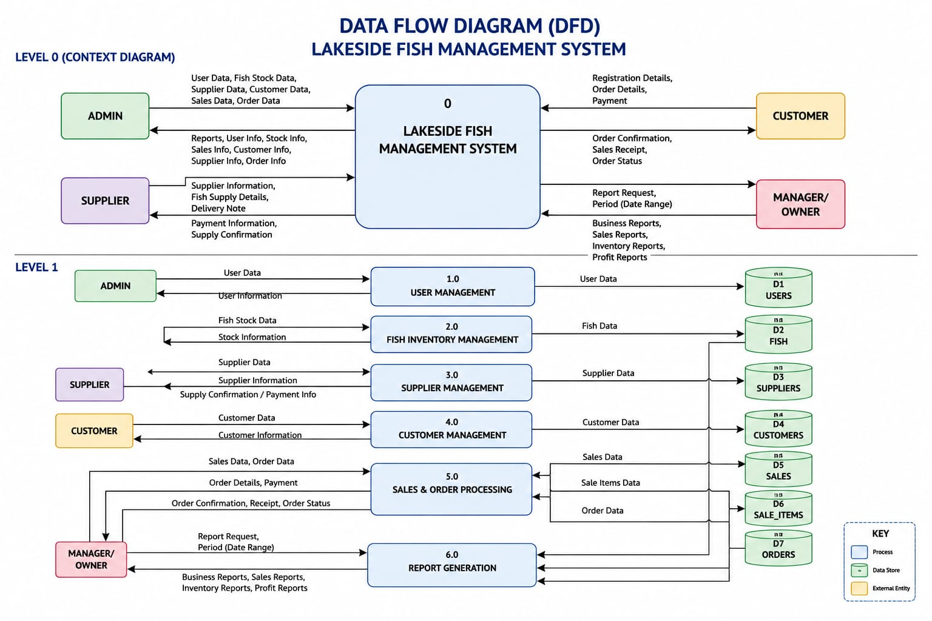

4.7.3 Entity Relationship Diagram
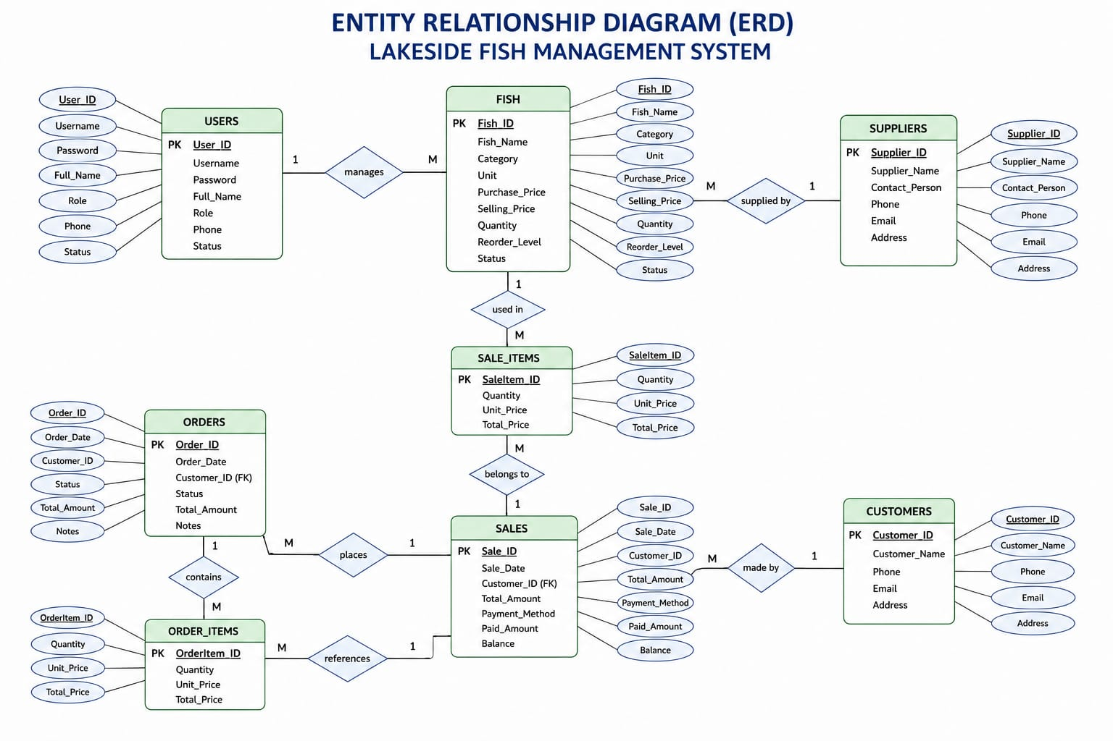

4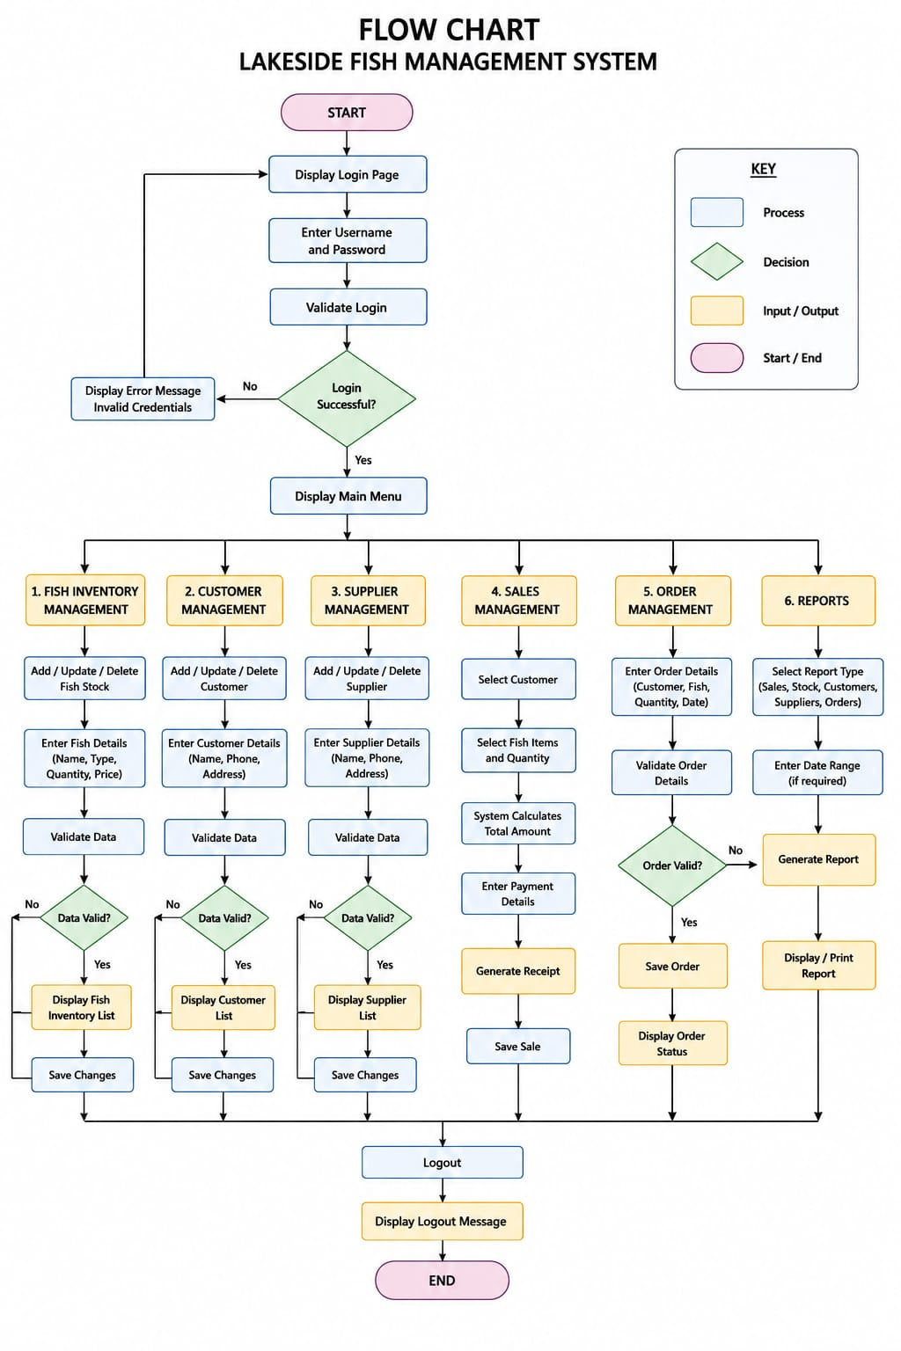

References
- Coronel, C., & Morris, S. (2020). Database systems: Design, implementation, and management (13th ed.). Cengage Learning.
- Dennis, A., Wixom, B. H., & Tegarden, D. (2021). Systems analysis and design: An object-oriented approach with UML (6th ed.). Wiley.
- Elmasri, R., & Navathe, S. B. (2021). Fundamentals of database systems (7th ed.). Pearson.
- Kendall, K. E., & Kendall, J. E. (2020). Systems analysis and design (10th ed.). Pearson.
- Laudon, K. C., & Laudon, J. P. (2022). Management information systems: Managing the digital firm (17th ed.). Pearson.
- Pressman, R. S., & Maxim, B. R. (2020). Software engineering: A practitioner's approach (9th ed.). McGraw-Hill Education.
- Sommerville, I. (2020). Software engineering (10th ed.). Pearson.
- Silberschatz, A., Korth, H. F., & Sudarshan, S. (2020). Database system concepts (7th ed.). McGraw-Hill Education.
- Connolly, T., & Begg, C. (2020). Database systems: A practical approach to design, implementation and management (6th ed.). Pearson.
- Rosenblatt, H. J. (2020). Systems analysis and design. Cengage Learning.
- PHP Documentation Group. (2025). PHP Manual. https://www.php.net/docs.php
- Apache Friends. (2025). XAMPP. https://www.apachefriends.org/
- Oracle Corporation. (2025). MySQL documentation. https://dev.mysql.com/doc/
- W3Schools. (n.d.). PHP Tutorial. https://www.w3schools.com/php/
- Mozilla Developer Network. (2025). HTML: Hypertext Markup Language. https://developer.mozilla.org/docs/Web/HTML
- Mozilla Developer Network. (2025). CSS: Cascading Style Sheets. https://developer.mozilla.org/docs/Web/CSS
- Mozilla Developer Network. (2025). JavaScript Guide. https://developer.mozilla.org/docs/Web/JavaScript
- Bootstrap Authors. (2025). Bootstrap Documentation. https://getbootstrap.com/docs/
- World Wide Web Consortium (W3C). (2025). Web Standards. https://www.w3.org/
- Fish Base. (2025). Fish Base: A global information system on fishes. https://www.fishbase.se/

